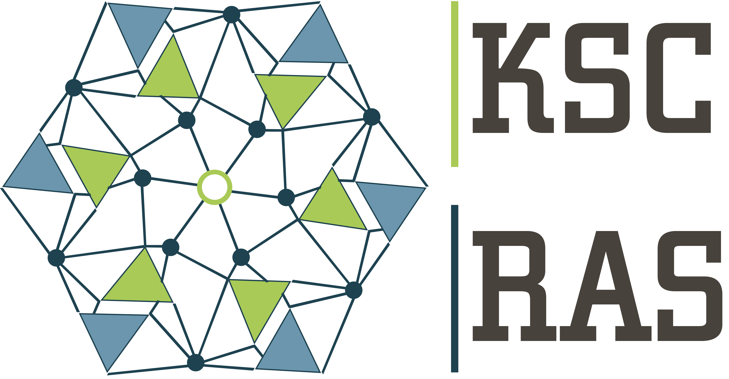 | Federal Research Centre «Kola Science Centre of the Russian Academy of Sciences» (FRC «KSC RAS»)

VISA SUPPORT FORM
Information for visa processing has to be provided by a foreign partner (applicant) to a partner on the Russian side. To get a visa support invitation or the invitation letter the following information is needed for every person invited. By filling and sending in this form the applicant gives a permission to FRC “KSC RAS” to use the personal data for the purposes mentioned in this form.
Surname (with uppercase letters)
First name (-s)
Date of birth (dd/mm/yy)
Sex
Actual citizenship (give also second citizenship if applicable)
Place of birth: country, region, city
Country and place of residence
In the consulate of which city are you going to receive your visa?
Place of employment (full name of your company, address, phone)
Address of the organization
E-mail address to send the scanned invitation
Position (occupation)
Passport number
Place and date of issue
Date of expiry
Purpose of visit
Intended date of entry to Russia/ Intended date of departure from Russia
Type of visa (single, double, multiple)
Cities or places in Russia to be visited, including transit cities

* Notification: This form and all the information attached will be kept confidential by KSC RAS and will only be used to process the letter of invitation
** Please return the file (WORD) named as VSF_Surname (e.g. VSF_Petrov)

