TITLE OF ABSTRACT

Surname N.N.¹, Surname N.N.²
¹ Affiliation, City, Country, e-mail@mail.mail
² Affiliation, City, Country

Text of abstract

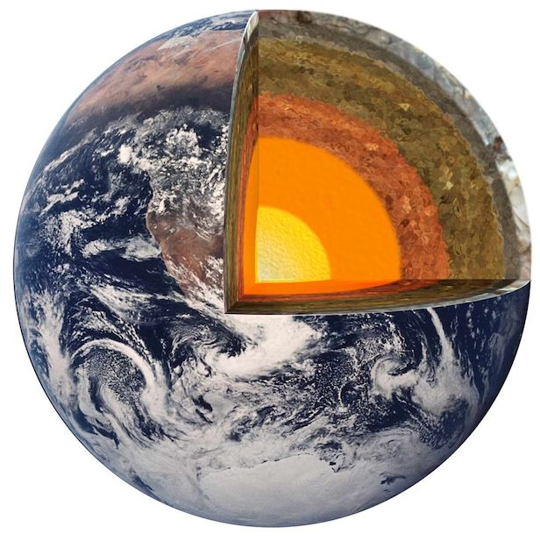  a | 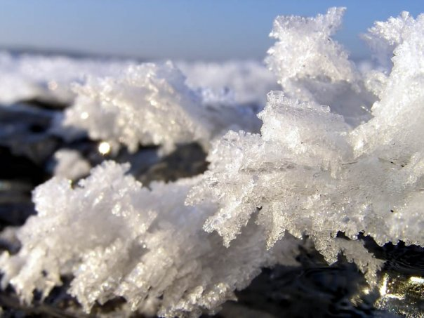  b
Fig. 1. Comments

Table 1. A table caption (title).
CaO
PbO

Source of financial support (if applicable).

References:
Artic L.E., Baquet G, Berthoin S, Thevenet D, Nourry C, Nottin S, Bosquet L (2009) Effect of high intensity intermittent training on heart rate variability in prepubescent children. Eur J Appl Physiol 105:731-738.

Boo K., Blass B. (2001) The future of modern genomics. Blackwell, London

Chapter I.N. Boo K. (2001) The politics of nature. In: Smith J (ed) The rise of modern genomics, 3rd edn. Wiley, New York, pp 230-257]

Interne T. Pag E.S. (2007) Big stars have weather too. IOP Publishing PhysicsWeb. http://physicsweb.org/articles/news/11/6/16/1.

Synops .I.S. (2016) Problems experimental analytics. Synopsis of the DrSci Dissertation, Moscow State University

Thesi S.E.S. (1975) Experimental acute renal failure. Dissertation PhD, University of California

